TITLE OF THE PAPER

First A. Author1*, Second B. Author2, Third C. Author1 …

1University of Belgrade, Faculty of Mechanical Engineering, Department of Information Technologies, 11000 Belgrade, Serbia

monGeometrija2021@gmail.com

*ABSTRACT*

*The author(s) should write what the aims of the paper are up to 250 words. Author(s) should use font style Arial, Italic, font size 10 pt, double-sided alignment and line spacing 1.*

Keywords: Please provide up to 5 keywords (Font style Arial, font size 10 pt), computer graphics; photogrammetry; computer science, applied geometry

1. GENERAL INFORMATION

Two versions of the Conference Proceedings will be provided:

* an electronic version (‘The Electronic Proceedings’), and
* a printed version (‘The Book of Abstracts’).

The Electronic Proceedings will consist of all accepted Papers (in full) while the printed version will consist of Extended Abstracts only (as shortened versions of the corresponding Papers).

The Paper (and its Extended Abstract) have to be written in English only. Both submitted documents will be reviewed prior to the final acceptance. The Paper will be published only if it is accepted together with its Extended Abstract.

The Paper should be structured so as to gain: a description of the problem investigated, an application field that the problem belongs to, research stages performed, methods used, results obtained, conclusions formulated, description of other research planned/needed, and the listing of all references cited.

The Paper and its Extended Abstract must have the identical Title as well as the authors’ order of appearance.

The formatting styles that should be applied on the Paper and on its corresponding Extended Abstract are the same for all their sections that are in common[1].

2. PAPER LENGTH AND ITS CONSTITUENTS

The body text of the Paper should start with an introduction, followed by the main body of text, and completed with conclusions, followed by a list of references. But, if appropriate, the Paper should be finalized with Acknowledgements and Notes on contributor(s) (if any). A Paper with no appendices is required. Footnotes should be placed at the bottom of the page of their first mention.

The structure of the main body of the Paper is up to the Author(s), and it should be logically defined respecting the already pointed-out section-hierarchy in general and sized so that the total number of pages does not exceed 16

(including all footnotes, figures, tables, references, acknowledgement(s) (if any) and notes on contributor(s)). The first (Title-page) will be right-sided (i.e. even).

2.1. Figures

The Image-layout (including necessary Caption-content) must be identical to that in the example below and scaled properly. Each Figure should be centred.

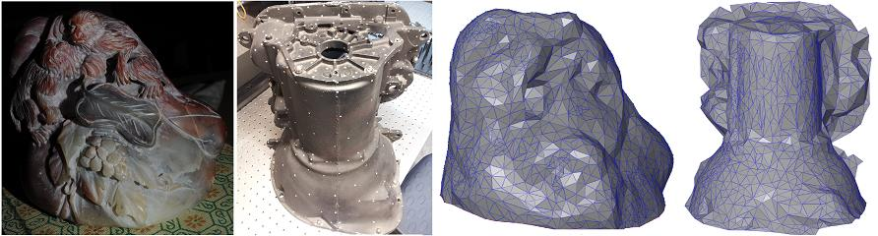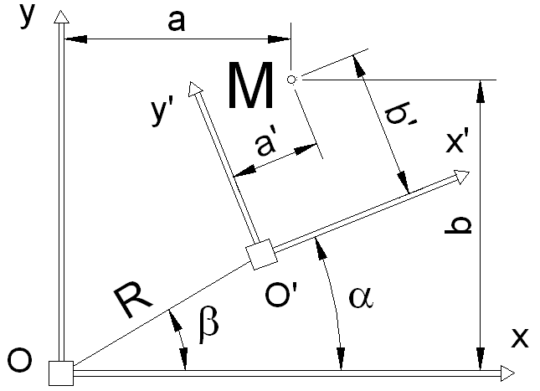

(a) (b)

**Figure. 1**: (a) Virtual model of the location, and (b) An image example of different nature

(Source: Johansen et al. (2012); illustrations modified with the Author’s written permission

Images/photos embedded have to be in one of the following formats: JPG,TIFF and PNG (minimum of 300 dpi should be used).

2.2 Tables

The table layout must be identical to that in the example below. Each Table should be centred. Tables must not be in the form of spread-sheets but WinWord created.

|  |  |  |  |  |  |  |  |
| --- | --- | --- | --- | --- | --- | --- | --- |
| Site | Adjusted  R2 | Mean error (m) | Standard deviation  of error (m) | % of points  ‘‘good’’ | % of points  ‘‘fair’’ | % of points  ‘‘poor’’ | Codes of points interpolated |
| Full site | 99.96 | 0.320 | 0.154 | 16.7 | 40.9 | 31.6 | 10 B 8 |
| Sub-scene | 98.32 | 0.310 | 0.165 | 25.7 | 27.9 | 35.2 | 11 B 2 |

**Table 1**: The parameters defined for different tests   
(Source: Johansen et al. (2012); Table reproduced with the Author’s written permission)

2.3 Mathematics

To respect proper mathematical conventions as well as to minimise the Author’s effort including that on the part of the copyeditors, the usage of Math-Editor is suggested. Each equation should be left-positioned while its naming should be right-positioned (as follows):

 ( Eq.1)

 ( Eq.2)

2.4 Displayed Quotations

‘Displayed quotations ought to be indicated by ‘single’ quotation marks (‘) and positioned in the text.

Only ‘longer’ quotations (with more then 40 words) must be located separately, indented and formatted in this way’.

2.5 Sections Hierarchy

2.5.1. Introduction

The introduction should provide both: an overview of the topic (stating the objectives of the current work) and a concise appraisal of prior work in the research field (avoiding a detailed literature survey or a summary of the previously established results). Introduction should include references to other publications that provide the reader with the sources relevant to the context of the current contribution and its research background.

2.5.2. Material and Methods Used

This section should provide sufficient information about the material and methods - used for reproduction of the actual scientific work/experiments. The already published methods should be indicated with a reference, bearing in mind that only important/significant modification of such ‘known’ methods should be used.

### 2.5.3. Research Fundamentals

This section should obtain theoretical and/or practical foundation necessary for the current scientific investigation, using references to relevant sources only (not repeating the already cited background to the Paper dealt with in the introductory section).

### 2.5.4. Discussion

This section should explore the significance of the results of the work, not repeat them. A combined Results and Discussion section is often more appropriate. Extensive citations and discussion of published literature have to be avoided here.

### 2.5.5. Conclusions

The concluding section should summarize the findings in a concise manner, but without undue repetition of the previous text. As previously mentioned, the main conclusions of the study may be presented in a short Conclusions section, which may stand alone or may form a subsection of either: a Discussion section or a ‘mixed’ Results and Discussion section.

### 2.5.6. Acknowledgements

Only sources of project funding (if any) MUST be acknowledged. Such acknowledgements should be collated in a separate section, located at the end of the body text of the Extended Abstract. Anonymous reviewers or the editors must not be acknowledged.

2.6 Page-breaking Rules

There must not be empty/blank rows between consecutive single- and multi-line sections, except in the case of respecting following ‘Page-breaking rules’ that Author(s) has to apply in the final text-processing pass.

Those ‘Page-breaking rules’ are:

* •No headings of any level must be located at the bottom of a page - without a minimum of 2 ending rows of subsequent text: if else, the headings must be pushed up to the very top of the next page,
* •In case of enumeration, at least one numbered (or bulleted) item should be placed immediately after the introductory sentence at the same page. If it is not possible, the introductory sentence should be moved to the beginning of the following page,
* •The total number of pages must be even, and
* •The last page must be completed at a rate off at least 50%.

3. REFERENCES

Unpublished results and inter-personal communication are not recommended in the reference list, but may be mentioned in the text (if these references are included in the reference list they should follow the reference style shown below – including a substitution of the publication date with one of the following notes: either with ‘Unpublished results’ or with ‘Personal communication’. Citation of a reference as ‘in press’, implies the fact that ‘it has already been accepted for publication’).

Depending on the required formulation, the referenced material can be cited so as to obtain:

* •Direct reference to the Author surname and the year of publishing, such as: ‘… in this research Higlemann (1984) demonstrated that …’, or
* •Indirect reference to the Author surname and the year of publishing, – positioned together in brackets (and separated by semi-colons in the case of multiple task-references), such as: ‘… these research results (higlemann, 1984; Higimotto, 2005) can be …’

Additionally, if there is a reference item prepared by:

* One Author – the surname have to be cited in the text, followed by the year of publishing: (Ittleman, 2010), or
* Two or more Authors - only the first one should be cited, followed by ‘et al.’ abbreviation and the year of publishing: (Hakimotto et al.., 2013).

The reference list should be alphabetically ordered (by the surname of the first Author) and formatted (by using its own style: ‘References’). That list must have at least 2 relevant items.

According to a concrete type of reference item, there are several possibilities:

Referencing to articles that have appeared in periodicals:

1. Chandler, J. H. and Padfield, C. J., 1996. *Automated digital photogrammetry on a shoestring. Photogrammetric Record*, 15(88). pp 545–560.

Referencing to books:

1. Wolf, P. R., 1983. *Elements of Photogrammetry*. Second edition. McGraw-Hill, New York, USA.

Referencing to edited books:

1. Wise, S. M., 1998. The effects of GIS interpolation errors on the use of digital elevation models in geomorphology. Chapter 7 in *Landform Monitoring, Modelling and Analysis* (Eds. S. N. Lane, K. S. Richards and J. H. Chandler). Wiley, Chichester. pp 139–164.

Referencing to Papers that have appeared in a long-running series of various Archives, even if they appeared on CD-ROM firstly or as to a loose Papers at the Workshops, Symposiums or Congresses:

1. Tovari, D. and Pfeifer, N., 2005. Segmentation based robust interpolation – a new approach to laser data filtering. *International Archives of Photogrammetry, Remote Sensing and Spatial Information Sciences*, 36(3/W19). pp 79–84.

Referencing to edited Conference Proceedings:

1. Fourstner, W. and Guilch, E., 1987. A fast operator for detection and precise location of distinct points, corners and centres of circular features. Proceedings of ISPRS Intercommission Conference on Fast Processing of Photogrammetric Data, Interlaken, Switzerland. pp. 281–305.

Referencing to Web-sites:

1. DETR, 1998. http://www.construction.detr.gov.uk/cis/rethink/6.htm [Accessed: 1st December 1999].

1. Generally, a text of both the Paper and the Extended Abstract has to be prepared IDENTICALLY